### **Summary Report for Big Mountain Resort**

**Problem statement**

By analyzing the data from 330 resorts, including Big Mountain Resort, we can identify key factors that influence ticket pricing and visitor distribution. We hypothesize that a data-driven pricing strategy will enable Big Mountain Resort to set more competitive and profitable ticket prices which will lead to an increase of revenue by 20% within the next financial year. Additionally, optimizing the utilization of facilities and exploring cost-cutting measures that do not impact customer satisfaction can further enhance revenue.

#### **Data Wrangling**

Original Dataset: 330 rows and 27 columns, including Big Mountain Resort.

Addressed Missing Values: Focused on the 'fastEight', 'yearsOpen', and 'SkiableTerrain_ac' columns. Replaced erroneous values in the 'SkiableTerrain_ac' column and dropped the 'fastEight' column due to mostly missing and zero values. Removed rows with missing ticket price data, resulting in 8 rows being excluded.

Reviewed Distribution and Outliers: Identified potential outliers and noted columns lacking variability.

State-wide Summary Statistics: Calculated total skiable area, days open, terrain parks, and night skiing area for each state.

Cleaned Dataset: After cleaning and preprocessing, retained 277 rows of data and 25 columns, with 'AdultWeekend' as the target feature.

#### **Exploratory Data Analysis**

The exploratory data analysis (EDA) phase involved deeper examination and visualization of the data to identify trends and patterns:

State-wise Summary: Analyzed the top states by skiable area, population, and resort density to understand regional differences in the ski industry.

Applied PCA transformation and created scatter plots to visualize high-dimensional data and explore correlations between numeric features and ticket prices.

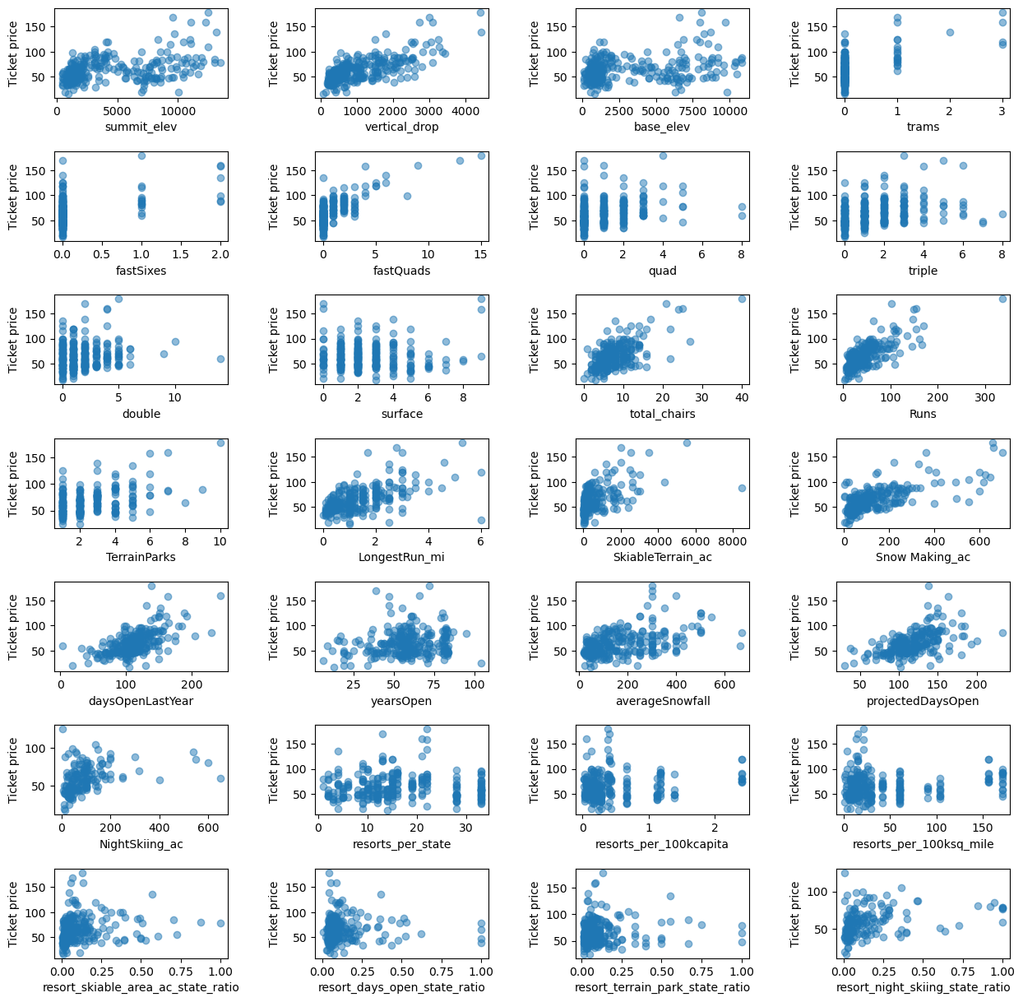

#### **Preprocessing and Initial Modeling**

Preprocessing steps included splitting the data into training and testing sets, imputing missing values, and scaling the data. Baseline models were created to set a performance benchmark. Metrics such as R-squared, Mean Absolute Error (MAE), and Mean Squared Error (MSE) were used to evaluate model performance.

| **Model** | Train MAE | Test MAE | Key Insights |
| --- | --- | --- | --- |
| **Initial Model** | 8.54 | 9.4 | Provided a baseline with minimal feature engineering. Highlighted the need for more complex models. |
| **Linear Regression** | 10.5 | 11.79 | Identified significant features such as vertical drop and snow-making capabilities. Good baseline performance but limited in capturing complex relationships. |
| **Random Forest Regressor** | 9.64 | 9.54 | Outperformed the linear regression model, indicating superior ability to handle complex, non-linear relationships. Important features included fastQuads, Runs, Snow Making_ac, and vertical_drop. |

#### **Winning Model and Scenario Modelling**

The winning model for Big Mountain Resort was a random forest model, which outperformed other models in terms of predictive accuracy. Key features that influenced ticket pricing included vertical drop, snow-making area, total number of chairs, fast quads, runs, longest run, trams, and skiable terrain area.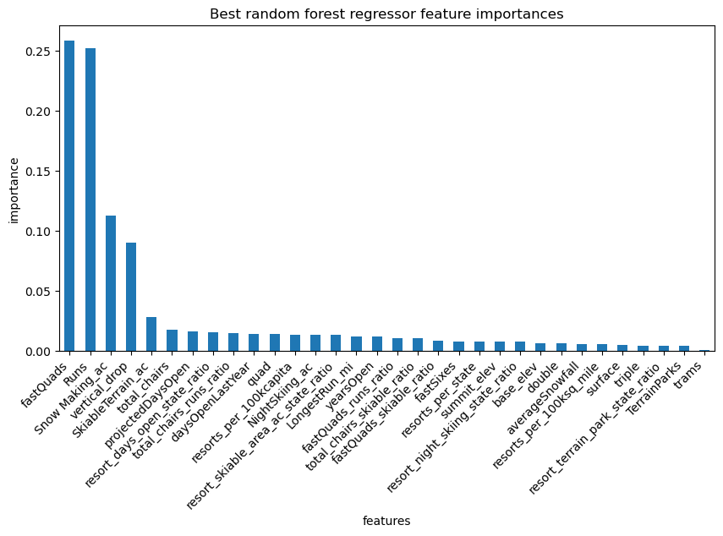

**Scenario Modeling**

1.Closing Runs: Closing one run showed no impact on price. Closing two to three runs reduced support for the ticket price, suggesting some elasticity. Closing more than three runs resulted in a significant price drop.

2.Vertical Drop and New Chair Lift: Increasing the vertical drop by adding a new run and installing an additional chair lift supported a ticket price increase by $1.99, potentially generating an additional $3.47 million in revenue.

3.Adding Snow-Making Area: Adding 2 acres of snow-making area in addition to the above scenario showed no significant difference in ticket price increase.

4.Longest Run Extension: Extending the longest run by 0.2 miles and adding 4 acres of snow-making coverage showed no significant impact on the ticket price.

**Pricing Recommendation**

Based on the model, Big Mountain Resort's current adult weekend ticket price of $81.00 is lower than the model's suggested price of $95.87. This indicates room for a price increase. A gradual increase towards the model-suggested price is recommended, with a phased approach to monitor customer response and market adjustments.

**Conclusion**

The modeling results suggest that Big Mountain Resort is potentially undercharging for its facilities. The key recommendation is to increase ticket prices gradually to align more closely with the model's suggested price. Additionally, expanding vertical drop and adding a new chair lift offer a promising revenue increase opportunity. However, run closures should be approached cautiously due to their potential negative impact on ticket prices.

**Future Scope of Work**

Future improvements could include:

Detailed Cost Data: Incorporating more granular cost data, including fixed and variable costs, marketing expenses, and historical cost trends.

Competitor Data: Gaining deeper insights into competitor pricing, offerings, and customer satisfaction.

Customer Satisfaction Data: Collecting customer satisfaction data to understand price elasticity better and identify areas for improvement.

Refinement and Validation: Continuously testing and refining the model with updated data and additional features to improve its accuracy and reliability.